Group Project (2 person)

TIS1101

(Database Fundamentals)

Food Ordering System

Table of Contents

Project Scope 1

Business Rules 1

Entity-Relationship Diagram (ERD) 2

Data Dictionary 3

Table creation query 4

Aggregate function (Syntax) 8

**Aggregate function (Screenshots)** 8

**Aggregate function (Explanation)** 9

Group by and having clause query (Syntax) 9

**Group by and having clause query (Screenshots)** 9

**Group by and having clause query (Explanation)** 10

Trigger 1 (Syntax) 11

**Trigger 1 (Screenshots)** 11

**Trigger 1 (Explanation)** 11

Trigger 2 (Syntax) 12

**Trigger 2 (Screenshots)** 12

**Trigger 2 (Explanation)** 13

Trigger 3 (Syntax) 13

**Trigger 3 (Screenshots)** 13

**Trigger 3 (Explanation)** 14

Stored Procedure (Syntax) 15

**Stored Procedure (Screenshots)** 15

**Stored Procedure (Explanation)** 16

View (Syntax) 17

**View (Screenshots)** 17

**View (Explanation)** 17

Sub queries (Syntax) 18

**Sub queries (Screenshots)** 18

**Sub queries (Explanation)** 19

Query not covered 1 (Syntax) 20

**Query not covered 1 (Screenshots)** 20

**Query not covered 1 (Explanation)** 21

Query not covered 2 (Syntax) 22

**Query not covered 2 (Screenshots)** 22

**Query not covered 2 (Explanation)** 23

Value Insertion Query (Customer) 24

Insert Query (Employee) 25

Insert Query (Cuisine_Type) 26

Insert Query (Menu) 27

Insert Query (Product_Info) 28

Insert query (Invoice) 30

Insert Query (Invoice_Details) 31

# Project Scope

This database is designed for food ordering purposes. It will assist the administrator in the restaurant to keep track and analyze valuable data that will play a part the restaurant’s business decision making process. The idea behind this is that this is a multi-cuisine type restaurant. The customers will enter the restaurant and order their food from a tablet on their table. An employee will bring the food out once it is ready to be served and all valuable data are kept in this database.

# Business Rules

1. A customer appears in one or many invoice.
2. An employee may generate many invoices.
3. An invoice has many invoice details.
4. A product info may appear in many invoice details.
5. A menu has many product details.
6. A cuisine type belongs to many Menu item.

# Entity-Relationship Diagram (ERD)



# Data Dictionary

|  |  |  |  |  |  |  |
| --- | --- | --- | --- | --- | --- | --- |
| TABLE NAME | ATTRIBUTE NAME | CONTENTS | TYPE | FORMAT | PK OR FK | FK REFERENCED TABLE |
| CUSTOMER | CUST_ID  CUST_NAME  CUST_PHONE  CUST_STATE  CUST_CITY  CUST_STREET  CUST_POSCODE | Customer’s ID  Customer’s Name  Customer’s Phone  Customer’s Address(State)  Customer’s Address(City)  Customer’s Address(Street name)  Customer’s Address(Poscode) | VARCHAR(10)  VARCHAR(40)  VARCHAR(15)  VARCHAR(20)  VARCHAR(20)  VARCHAR(50)  VARCHAR(10) | CUSTxxxx  Xxxxxxxx  Xxxxxxxx  Xxxxxxxx  Xxxxxxxx  Xxxxxxxx  Xxxxxxxx | PK |  |
| EMPLOYEE | EMP_ID  EMP_NAME  EMP_POSITION | Employee’s ID  Employee’s name  Employee’s rank | VARCHAR(10)  VARCHAR(40)  VARCHAR(20) | EMPxxxx  Xxxxxxxx  Xxxxxxxx | PK |  |
| INVOICE | INVOICE_ID  INVOICE_DATE  INVOICE_TOTALPRICE  TABLE_NO  EMP_ID  CUST_ID | Invoice’s ID  Invoice’s date  Invoice’s total price  Table number  Employee’s ID  Customer’s ID | VARCHAR(10)  DATE  DECIMAL(7,2)  INT  VARCHAR(10)  VARCHAR(10) | INVxxxx  yyyy-mm-dd  99999.99  99999  EMPxxxx  CUSTxxxx | PK  FK  FK | EMPLOYEE  CUSTOMER |
| INVOICE_DETAILS | DETAILS_ID  DETAILS_PRICE  DETAILS_QTY  INVOICE_ID  PROD_INFO_ID | Details’ ID  Details’ Price  Details’ Quantity  Invoice’s ID  Product Info’s ID | VARCHAR(10)  DECIMAL(5,2)  INT  VARCHAR(10)  VARCHAR(10) | DETxxxx  999.99  99999  INVxxxx  PIxxxx | PK  FK  FK | INVOICE  PRODUCT_INFO |
| PRODUCT_INFO | PROD_INFO_ID  PROD_INFO_SIZE  PROD_INFO_PRICE  PROD_ID | Product Info’s ID  Product Info’s size  Product Info’s Price  Product’s ID | VARCHAR(10)  CHAR(1)  DECIMAL(5,2)  VARCHAR(10) | PIxxxx  X  999.99  Pxxxx | PK  FK | MENU |
| MENU | PROD_ID  PROD_NAME  PROD_TYPE  CTYPE_ID | Product’s ID  Product Name  Product Type  Cuisine Type | VARCHAR(10)  VARCHAR(40)  VARCHAR(20)  VARCHAR(10) | Pxxxx  Xxxxxxx  Xxxxxxx  CTxxxx | PK  FK | CUISINE_TYPE |
| CUISINE_TYPE | CTYPE_ID  CTYPE_NAME | Cuisine Type ID  Cuisine Type Name | VARCHAR(10)  VARCHAR(20) | CTxxxx  Xxxxxx | PK |  |

# Table creation query

Create database asgn;

Connect to asgn;

Create table Customer

(

Cust_ID varchar(10) not null,

Cust_Name varchar(40),

Cust_Phone varchar(15),

Cust_State varchar(20),

Cust_City varchar(20),

Cust_Street varchar(50),

Cust_Poscode varchar(10),

Primary key(Cust_ID)

);

Create table Employee

(

Emp_ID varchar(10) not null,

Emp_Name varchar(40),

Emp_Position varchar(20),

Primary key(Emp_ID)

);

Create table Invoice

(

Invoice_ID varchar(10) not null,

Invoice_Date date,

Invoice_TotalPrice decimal(7,2),

Table_no int,

Emp_ID varchar(10),

Cust_ID varchar(10),

Primary key(Invoice_ID),

Foreign key(Emp_ID) references Employee,

Foreign key(Cust_ID) references Customer

);

Create table Cuisine_Type

(

CType_ID varchar(10) not null,

CTypeName varchar(20),

Primary key(CType_ID)

);

Create table Menu

(

Prod_ID varchar(10) not null,

Prod_Name varchar(40),

Prod_Type varchar(20),

CType_ID varchar(10),

Primary key(Prod_ID),

Foreign key(CType_ID) references Cuisine_Type

);

Create table Product_Info

(

Prod_Info_ID varchar(10) not null,

Prod_Info_Size char(1),

Prod_Info_Price decimal(5,2),

Prod_ID varchar(10),

Primary key(Prod_Info_ID),

Foreign key(Prod_ID) references Menu

);

Create table Invoice_Details

(

Details_ID varchar(10) not null,

Details_Price decimal (7,2),

Details_Qty int,

Invoice_ID varchar(10),

Prod_Info_ID varchar(10),

Primary key(Details_ID),

Foreign key(Invoice_ID) references Invoice,

Foreign key(Prod_Info_ID) references Product_Info

);

# Aggregate function (Syntax)

Create trigger inv_totalPriceIns

after insert on Invoice_Details

referencing new as n

for each row mode db2sql

update Invoice

set Invoice_TotalPrice = (select sum(Details_Price) from Invoice_Details

where Invoice_Details.Invoice_ID= n.Invoice_ID)

where Invoice.Invoice_ID=n.Invoice_ID

## **Aggregate function (Screenshots)**

Before insert into Invoice_Details



After insert query into Invoice_Details

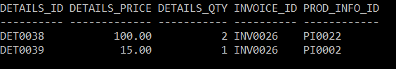

In Invoice with ID ‘INV0026’ there are two items, one item of quantity 2 with final price of 100.00 and another item of quantity 1 with final price of 15.00

The resulting total price in Invoice table for invoice ‘INV0026’ is the sum of both prices of the same invoice ID:

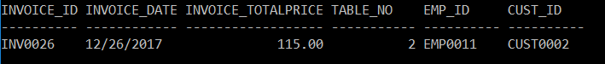

## **Aggregate function (Explanation)**

This is a trigger with aggregate function. This trigger will trigger after a new record is inserted into Invoice_details whereby it update the Invoice_TotalPrice in Invoice to ensure the total price of that particular invoice updates along when new record is inserted into Invoice_Details.

# Group by and having clause query (Syntax)

Create view regularcust(Cust_Name,Num_Visit) as select cust_name,count(*) from Invoice, Customer where Invoice.Cust_ID=Customer.Cust_ID group by cust_Name having count(*)>5

Select * from regularcust order by num_visit desc

## **Group by and having clause query (Screenshots)**

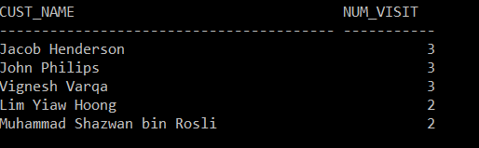

## **Group by and having clause query (Explanation)**

This is a view with ‘group by’ and ‘having’ clause implemented. This view consist of two columns Customer’s name and his/her number of visit. The view will group by Customer’s name and will only display records with more than 5 visits to the premise.

# Trigger 1 (Syntax)

create trigger get_detailsPrice

after insert on Invoice_Details

referencing new as n

for each row mode db2sql

update Invoice_Details

set Details_Price = (select Prod_Info_Price*Details_Qty from Product_Info,Invoice_Details where Product_Info.prod_info_ID=Invoice_details.prod_info_ID and Invoice_details.details_id=n.details_id )

where Invoice_Details.Details_ID= n.Details_ID

## **Trigger 1 (Screenshots)**

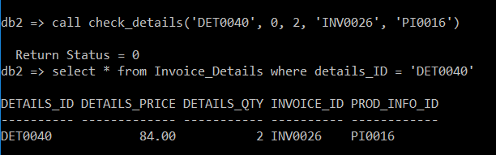

## **Trigger 1 (Explanation)**

The trigger get_detailsPrice will trigger after a new record is inserted into Invoice_details. The trigger will calculate the details’ price according to the value of the record entered. User may opt not to insert any value for details_price when they insert record into Invoice_Details as the details_price will automatically calculated by this trigger.

# Trigger 2 (Syntax)

create trigger get_detailsPriceUpd

after update of Details_qty on Invoice_Details

referencing new as n

for each row mode db2sql

update Invoice_Details

set Details_Price = (select Prod_Info_Price*Details_Qty from Product_Info,Invoice_Details where Product_Info.prod_info_ID=Invoice_details.prod_info_ID and Invoice_details.details_id=n.details_id )

where Invoice_Details.Details_ID= n.Details_ID

## **Trigger 2 (Screenshots)**

Before update

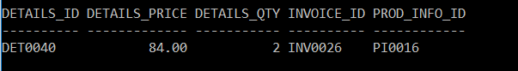

After update on Details_QTY

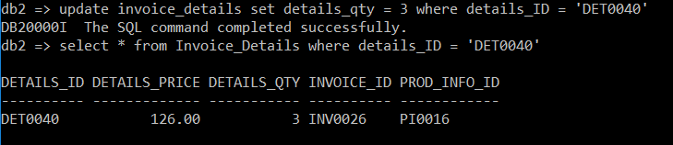

## **Trigger 2 (Explanation)**

The trigger get_detailsPrice will trigger after a details_qty is updated into Invoice_details. As an example user updated the quantity of the item (Details_Qty) which will affect the Details_Price to change. This trigger will recalculate the details’ price according to the updated details_qty.

# Trigger 3 (Syntax)

Create trigger inv_totalPriceUpd

after update on Invoice_Details

referencing new as n

for each row mode db2sql

update Invoice

set Invoice_TotalPrice = (select sum(Details_Price) from Invoice_Details

where Invoice_Details.Invoice_ID= n.Invoice_ID)

where Invoice.Invoice_ID=n.Invoice_ID

## **Trigger 3 (Screenshots)**

Before update on Invoice_Details in Invoice table:

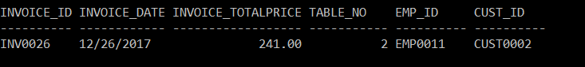

Before update on Invoice_Details in Invoice_Details table:

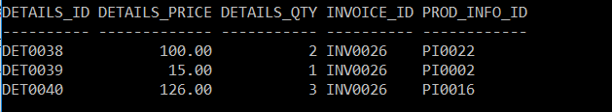

After update on Invoice_Details in Invoice_Details table:

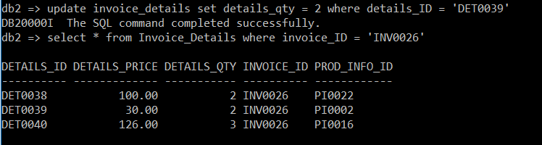

After update on Invoice_Details in Invoice table:

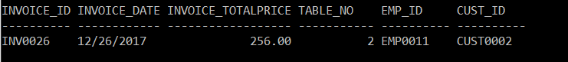

## **Trigger 3 (Explanation)**

The trigger inv_totalPriceUPD will trigger after any update in Invoice_details. As an example the user updated the quantity of item (Details_Qty). This will cause the total price in Invoice table to change hence this trigger will recalculate the Invoice_TotalPrice in Invoice.

# Stored Procedure (Syntax)

Create procedure check_details(in dID varchar(10),price decimal(5,2),Qty int,iID varchar(10),

Pid varchar(10))

begin

if pID not in(select prod_info_id from invoice_details where invoice_details.Invoice_ID=iID) then

insert into Invoice_details values(dID,Price,Qty,iID,pID);

else

Signal sqlstate ‘75001’ set message_text=’Cannot enter existing products into same invoices’;

end if;

end

## **Stored Procedure (Screenshots)**

Current Invoice_Details values:

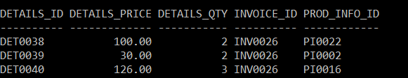

After trying to insert an Invoice details of the same invoice with an existing item:



## **Stored Procedure (Explanation)**

This stored procedure is used to insert values into Invoice_Details. This is an error checking stored procedure where it checks if the Prod_Info_ID entered has already exist in the same invoice. If it already exist, the user will be informed that they cannot enter existing product with same Invoice_ID. If it doesn’t exist, then the record will be entered.

# View (Syntax)

Create view topdish(Prod_info_ID,number) as select Prod_Info_ID,sum(details_qty) from Invoice_Details group by prod_info_id

## **View (Screenshots)**

Within the view it shows how many times the product has been orderer

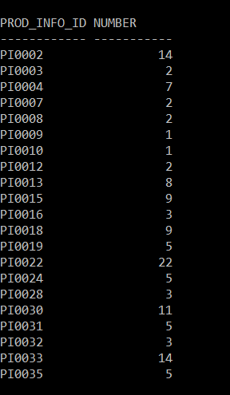

## **View (Explanation)**

This view is to display the top dish ordered by the customers.

# Sub queries (Syntax)

Create trigger inv_totalPriceDel after delete on Invoice_Details

referencing old as o

for each row mode db2sql

update Invoice

set Invoice_TotalPrice = (select sum(Details_Price) from Invoice_Details

where Invoice_Details.Invoice_ID= o.Invoice_ID)

where Invoice.Invoice_ID=o.Invoice_ID

## **Sub queries (Screenshots)**

Invoice total price before delete in Invoice_Details:

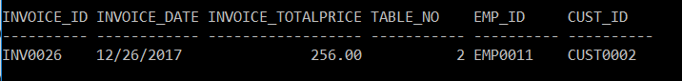

Invoice Details before delete:

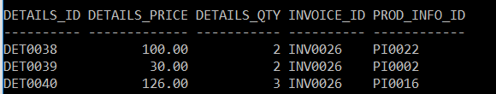

Invoice Details after delete:

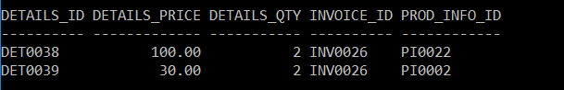

Invoice total price after delete in Invoice_Details:

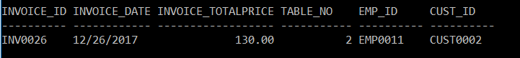

## **Sub queries (Explanation)**

This is a trigger with sub queries implemented. This trigger will trigger after a record is deleted from Invoice_Details table. If a record is deleted from Invoice_Details, it will cause the total price in Invoice to change hence this trigger will recalculate the total price in Invoice.

# Query not covered 1 (Syntax)

Select Prod_name, prod_info_size, number from menu, product_info, topdish where menu.prod_ID = product_info.prod_ID and product_info.prod_info_id = topdish.prod_info_ID order by number desc fetch first 3 rows only

## **Query not covered 1 (Screenshots)**

Values in the view ‘Topdish’

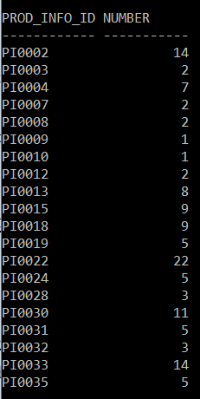

Using the select query above:

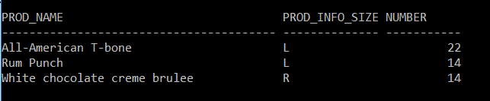

## **Query not covered 1 (Explanation)**

This query is paired with the query ‘fetch first 3 rows only’ to display the top 3 dish ordered from the view topdish.

# Query not covered 2 (Syntax)

Select Prod_name, prod_info_size, number from menu, product_info, topdish where menu.prod_ID = product_info.prod_ID and product_info.prod_info_id = topdish.prod_info_ID order by number asc limit 3

## **Query not covered 2 (Screenshots)**

Values in the view ‘Topdish’:



Using the select query above:

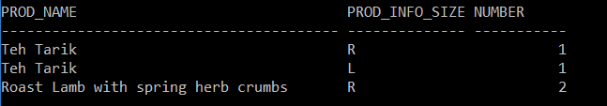

## **Query not covered 2 (Explanation)**

This query is paired with the query ‘limit’ to display the lower 3 dish order from the view topdish.

# Value Insertion Query (Customer)

insert into Customer values(‘CUST0001’,’John Philips’,’0114724586’,’Selangor’,’Kuala Lumpur’, ’Jalan Mahmud’,’68100’)

insert into Customer values (‘CUST0002’,’Jacob Henderson’,’0178996734’,’Pulau Pinang’,’Georgetown’, ’Jalan Brother James’,’107450’)

insert into Customer values (‘CUST0003’,’Hong Zhe Yean’,’0183459870’,’Kedah’,’Sungai Petani’, ’Jalan Clover 6’,’433575’)

insert into Customer values(‘CUST0004’,’Lim Yiaw Hoong’,’0127778780’,’Selangor’,’Batu Caves’, ’Jalan Ehsan’,’25077’)

insert into Customer values(‘CUST0005’,’Muhammad Fitri bin Kamarudin’,’0134531298’, ’Kelantan’, ’Bachok District’, ’Jalan Pantai Aman’,’56080’)

insert into Customer values(‘CUST0006’,’Muhammad Firzani bin Fauzi’,’0165739855’, ‘Selangor’, ’Klang’, ’Jalan Goh Hock Huat’,’41400’)

insert into Customer values(‘CUST0007’,’Somraaj a/l Muthu’,’0182213455’,’Pulau Pinang’, ’Bayan Lepas’, ’Lebuh Sungai Ara 1’,’11900’)

insert into Customer values(‘CUST0008’,’Nancy Flowers’,’0124548886’,’Pulau Pinang’,’Gelugor’,’Jalan Permai’,’11700’)

insert into Customer values(‘CUST0009’,’Vignesh Varqa’,’0138907890’,’Selangor’,’Puchong’, ’Persiaran Kewajipan’,’47600’)

insert into Customer values(‘CUST0010’,’Muhammad Shazwan bin Rosli’,’0187734590’, ’Johor’, ’Senai’, ’Jalan Murni 12’,’81400’)

insert into Customer values(‘CUST0011’,’Soganraaj a/l Muniandy’,’0128890456’,’Johor’, ’Muar’, ’Jalan Sungai Abong’,’84000’)

insert into Customer values(‘CUST0012’,’Christopher Nolan’,’0164557890’, ’Pulau Pinang’, ’Georgetown’, ’Jalan Gurney Drive’,’10470’)

insert into Customer values(‘CUST0013’,’Leonard Ng’,’0139906566’,’Pulau Pinang’, ’Bayan Lepas’, ’Pintasan Kenari’,’11900’)

insert into Customer values(‘CUST0014’,’Daryl Cheah’,’0182215580’,’Selangor’,’Kapar’, ’Jalan Mohammad Ikram’,’45600’)

insert into Customer values(‘CUST0015’,’Muhammad Afiq bin Ali’,’0145368877’, ’Kelantan’, ’Kuala Krai’, ’Jalan Mutiara’,’18050’)

insert into Customer values(‘CUST0016’, ’Muhammad Aminah binti Samsudin’,’0128904561’,’Pahang’,’Kuantan’,’Jalan Sungai Lembing’,’28000’)

insert into Customer values(‘CUST0017’,’Yasmin Yacob’,’0168984572’,’Negeri Sembilan’, ’Gemas’, ’Jalan DS 3’,’73400’)

insert into Customer values(‘CUST0018’,’George Lucas’,’0136722385’,’Perlis’,’Kangar’, ’Persiaran Jubli Emas’,’01000’)

# Insert Query (Employee)

Insert into Employee values (‘EMP0001’,’Waylon Dalton’, ’Manager’)

Insert into Employee values (‘EMP0002’,’Teng Hock Lian’, ’Excutive Chef’)

Insert into Employee values (‘EMP0003’,’Mary Jane’, ’Sous Chef’)

Insert into Employee values (‘EMP0004’,’Muhammad Mohktar bin Khairi’,’Pastry Chef’)

Insert into Employee values (‘EMP0005’,’Somendiran a/l Muniandy’,’Soup and sauce Cook’)

Insert into Employee values (‘EMP0006’,’James Lee’, ’Sous Chef ’)

Insert into Employee values (‘EMP0007’,’Taro Misaki’,’Sous Chef’)

Insert into Employee values (‘EMP0008’,’Robin Dubos’, ’Fry Cook’)

Insert into Employee values (‘EMP0009’,’Hew Choon Yen’, ’Broiler Cook’)

Insert into Employee values (‘EMP0010’,’Dmitri Oleksander’,’Kitchen Manager’)

Insert into Employee values (‘EMP0011’,’Mohammad Taufik bin Umar’,’Waiter’)

Insert into Employee values (‘EMP0012’,’Hong Ming Kean’,’Waiter’)

Insert into Employee values (‘EMP0013’,’Lee Hui Yin’,’Waiter’)

Insert into Employee values (‘EMP0014’,’Frank Masson’,’Waiter’)

Insert into Employee values (‘EMP0015’,’Muhammad Khadija binti Omar’,’Waiter’)

# Insert Query (Cuisine_Type)

insert into Cuisine_Type values(‘CT0001’,’American’)

insert into Cuisine_Type values(‘CT0002’,’British’)

insert into Cuisine_Type values(‘CT0003’,’Carribean’)

insert into Cuisine_Type values(‘CT0004’,’Chinese’)

insert into Cuisine_Type values(‘CT0005’,’French’)

insert into Cuisine_Type values(‘CT0006’,’Greek’)

insert into Cuisine_Type values(‘CT0007’,’Indian’)

insert into Cuisine_Type values(‘CT0008’,’Italian’)

insert into Cuisine_Type values(‘CT0009’,’Japanese’)

insert into Cuisine_Type values(‘CT0010’,’Malaysian’)

insert into Cuisine_Type values(‘CT0011’,’Mediterranean’)

insert into Cuisine_Type values(‘CT0012’,’Mexican’)

insert into Cuisine_Type values(‘CT0013’,’Spanish’)

insert into Cuisine_Type values(‘CT0014’,’Thai’)

insert into Cuisine_Type values(‘CT0015’,’Turkish’)

insert into Cuisine_Type values(‘CT0016’,’Vietnamese’ )

# Insert Query (Menu)

insert into Menu values(‘P0001’,’Rum Punch’,’Beverage’,’CT0003’)

insert into Menu values(‘P0002’,’Roast lamb with spring herbs crumbs’,’Food’,’CT0002’)

insert into Menu values(‘P0003’,’British pork cassoulet’,’Food’,’CT0002’)

insert into Menu values(‘P0004’,’Nasi Lemak’,’Food’,’CT0010’)

insert into Menu values(‘P0005’,’Teh Tarik’,’Beverage’,’CT0010’)

insert into Menu values(‘P0006’,’Ambra and Sour Plum Juice’,’Beverage’,’CT0010’)

insert into Menu values(‘P0007’,’Beef Rendang’,’Food’,’CT0010’)

insert into Menu values(‘P0008’,’Fish head curry’,’Food’,’CT0010’)

insert into Menu values(‘P0009’,’Key lime pie’,’Desert’,’CT0001’)

insert into Menu values(‘P0010’,’Sticky ribs with roast potato salad’,’Food’,’CT0001’)

insert into Menu values(‘P0011’,’All-American T-bone’,’Food’,’CT0001’)

insert into Menu values(‘P0012’,’Fish tacos with Baja sauce’,’Food’,’CT0012’)

insert into Menu values(‘P0013’,’Michelada’,’Beverage’,’CT0012’)

insert into Menu values(‘P0014’,’Miso Soup’,’Food’,’CT0009’)

insert into Menu values(‘P0015’,’Katsu pork with sticky rice’,’Food’,’CT0009’)

insert into Menu values(‘P0016’,’Green tea frozen yogurt with sesame’,’Desert’,’CT0009’)

insert into Menu values(‘P0017’,’White chocolate creme brulee’,’Desert’,’CT0005’)

insert into Menu values(‘P0018’,’Citron Presse’,’Beverage’,’CT0005’)

# Insert Query (Product_Info)

Insert into product_info values(‘PI0001’,’R’,’10.00’,’P0001’)

Insert into product_info values(‘PI0002’,’L’,’15.00’,’P0001’)

Insert into product_info values(‘PI0003’,’R’,’25.00’,’P0002’)

Insert into product_info values(‘PI0004’,’L’,’32.00’,’P0002’)

Insert into product_info values(‘PI0005’,’R’,’26.00’,’P0003’)

Insert into product_info values(‘PI0006’,’L’,’32.00’,’P0003’)

Insert into product_info values(‘PI0007’,’R’,’13.50’,’P0004’)

Insert into product_info values(‘PI0008’,’L’,’16.00’,’P0004’)

Insert into product_info values(‘PI0009’,’R’,’8.00’,’P0005’)

Insert into product_info values(‘PI0010’,’L’,’10.00’,’P0005’)

Insert into product_info values(‘PI0011’,’R’,’11.00’,’P0006’)

Insert into product_info values(‘PI0012’,’L’,’13.50’,’P0006’)

Insert into product_info values(‘PI0013’,’R’,’24.50’,’P0007’)

Insert into product_info values(‘PI0014’,’L’,’31.50’,’P0007’)

Insert into product_info values(‘PI0015’,’R’,’35.00’,’P0008’)

Insert into product_info values(‘PI0016’,’L’,’42.00’,’P0008’)

Insert into product_info values(‘PI0017’,’R’,’23.50’,’P0009’)

Insert into product_info values(‘PI0018’,’L’,’30.00’,’P0009’)

Insert into product_info values(‘PI0019’,’R’,’36.00’,’P0010’)

Insert into product_info values(‘PI0020’,’L’,’42.00’,’P0010’)

Insert into product_info values(‘PI0021’,’R’,’40.00’,’P0011’)

Insert into product_info values(‘PI0022’,’L’,’50.00’,’P0011’)

Insert into product_info values(‘PI0023’,’R’,’23.50’,’P0012’)

Insert into product_info values(‘PI0024’,’L’,’30.00’,’P0012’)

Insert into product_info values(‘PI0025’,’R’,’17.00’,’P0013’)

Insert into product_info values(‘PI0026’,’L’,’20.00’,’P0013’)

Insert into product_info values(‘PI0027’,’R’,’12.50’,’P0014’)

Insert into product_info values(‘PI0028’,’L’,’14.50’,’P0014’)

Insert into product_info values(‘PI0029’,’R’,’24.00’,’P0015’)

Insert into product_info values(‘PI0030’,’L’,’28.00’,’P0015’)

Insert into product_info values(‘PI0031’,’R’,’16.00’,’P0016’)

Insert into product_info values(‘PI0032’,’L’,’20.00’,’P0016’)

Insert into product_info values(‘PI0033’,’R’,’23.00’,’P0017’)

Insert into product_info values(‘PI0034’,’L’,’26.50’,’P0017’)

Insert into product_info values(‘PI0035’,’R’,’12.00’,’P0018’)

Insert into product_info values(‘PI0036’,’L’,’15.50’,’P0018’)

# Insert query (Invoice)

Insert into invoice values (‘INV0001’,’2017-12-23’,0,2,’EMP0011’,’CUST0001’)

Insert into invoice values (‘INV0002’,’2017-12-23’,0,3,’EMP0012’,’CUST0002’)

Insert into invoice values (‘INV0003’,’2017-12-23’,0,1,’EMP0015’,’CUST0003’)

Insert into invoice values (‘INV0004’,’2017-12-23’,0,4,’EMP0011’,’CUST0004’)

Insert into invoice values (‘INV0005’,’2017-12-23’,0,6,’EMP0014’,’CUST0005’)

Insert into invoice values (‘INV0006’,’2017-12-23’,0,2,’EMP0013’,’CUST0006’)

Insert into invoice values (‘INV0007’,’2017-12-24’,0,1,’EMP0013’,’CUST0007’)

Insert into invoice values (‘INV0008’,’2017-12-24’,0,3,’EMP0014’,’CUST0002’)

Insert into invoice values (‘INV0009’,’2017-12-24’,0,2,’EMP0011’,’CUST0008’)

Insert into invoice values (‘INV0010’,’2017-12-24’,0,5,’EMP0014’,’CUST0009’)

Insert into invoice values (‘INV0011’,’2017-12-24’,0,6,’EMP0015’,’CUST0001’)

Insert into invoice values (‘INV0012’,’2017-12-24’,0,8,’EMP0013’,’CUST0010’)

Insert into invoice values (‘INV0013’,’2017-12-24’,0,7,’EMP0012’,’CUST0011’)

Insert into invoice values (‘INV0014’,’2017-12-24’,0,3,’EMP0011’,’CUST0012’)

Insert into invoice values (‘INV0015’,’2017-12-24’,0,1,’EMP0014’,’CUST0013’)

Insert into invoice values (‘INV0016’,’2017-12-26’,0,2,’EMP0011’,’CUST0004’)

Insert into invoice values (‘INV0017’,’2017-12-26’,0,1,’EMP0015’,’CUST0009’)

Insert into invoice values (‘INV0018’,’2017-12-26’,0,7,’EMP0014’,’CUST0014’)

Insert into invoice values (‘INV0019’,’2017-12-26’,0, 5,’EMP0011’,’CUST0015’)

Insert into invoice values (‘INV0020’,’2017-12-26’,0, 2,’EMP0012’,’CUST0016’)

Insert into invoice values (‘INV0021’,’2017-12-26’,0, 6,’EMP0013’,’CUST0017’)

Insert into invoice values (‘INV0022’,’2017-12-26’,0, 6,’EMP0015’,’CUST0001’)

Insert into invoice values (‘INV0023’,’2017-12-26’,0, 4,’EMP0014’,’CUST0009’)

Insert into invoice values (‘INV0024’,’2017-12-26’,0, 3,’EMP0012’,’CUST0010’)

Insert into invoice values (‘INV0025’,’2017-12-26’,0, 2,’EMP0013’,’CUST0018’)

# Insert Query (Invoice_Details)

Call check_details(‘DET0001’,0,2,’INV0001’,’PI0002’)

Call check_details(‘DET0002’,0,1,’INV0001’,’PI0009’)

Call check_details(‘DET0003’,0,3,’INV0002’,’PI0002’)

Call check_details(‘DET0004’,0,1,’INV0002’,’PI0003’)

Call check_details(‘DET0005’,0,2,’INV0003’,’PI0007’)

Call check_details(‘DET0006’,0,4,’INV0004’,’PI0030’)

Call check_details(‘DET0007’,0,2,’INV0005’,’PI0033’)

Call check_details(‘DET0008’,0,1,’INV0005’,’PI0022’)

Call check_details(‘DET0009’,0,2,’INV0006’,’PI0024’)

Call check_details(‘DET0010’,0,3,’INV0007’,’PI0019’)

Call check_details(‘DET0011’,0,5,’INV0008’,’PI0035’)

Call check_details(‘DET0012’,0,5,’INV0008’,’PI0004’)

Call check_details(‘DET0013’,0,2,’INV0009’,’PI0028’)

Call check_details(‘DET0014’,0,2,’INV0010’,’PI0015’)

Call check_details(‘DET0015’,0,3,’INV0011’,’PI0032’)

Call check_details(‘DET0016’,0,1,’INV0011’,’PI0022’)

Call check_details(‘DET0017’,0,3,’INV0012’,’PI0013’)

Call check_details(‘DET0018’,0,6,’INV0013’,’PI0030’)

Call check_details(‘DET0019’,0,2,’INV0014’,’PI0018’)

Call check_details(‘DET0020’,0,2,’INV0015’,’PI0012’)

Call check_details(‘DET0021’,0,2,’INV0015’,’PI0019’)

Call check_details(‘DET0022’,0,1,’INV0016’,’PI0010’)

Call check_details(‘DET0023’,0,1,’INV0016’,’PI0003’)

Call check_details(‘DET0024’,0,2,’INV0017’,’PI0008’)

Call check_details(‘DET0025’,0,3,’INV0018’,’PI0024’)

Call check_details(‘DET0026’,0,5,’INV0019’,’PI00031’)

Call check_details(‘DET0027’,0,5,’INV0019’,’PI0013’)

Call check_details(‘DET0028’,0,1,’INV0020’,’PI0028’)

Call check_details(‘DET0029’,0,1,’INV0020’,’PI0030’)

Call check_details(‘DET0030’,0,7,’INV0021’,’PI0015’)

Call check_details(‘DET0031’,0,2,’INV0022’,’PI0033’)

Call check_details(‘DET0032’,0,7,’INV0023’,’PI0018’)

Call check_details(‘DET0033’,0,2,’INV0023’,’PI0004’)

Call check_details(‘DET0034’,0,8,’INV0024’,’PI0022’)

Call check_details(‘DET0035’,0,7,’INV0024’,’PI0002’)

Call check_details(‘DET0036’,0,10,’INV0025’,’PI0022’)

Call check_details(‘DET0037’,0,10,’INV0025’,’PI0033’)